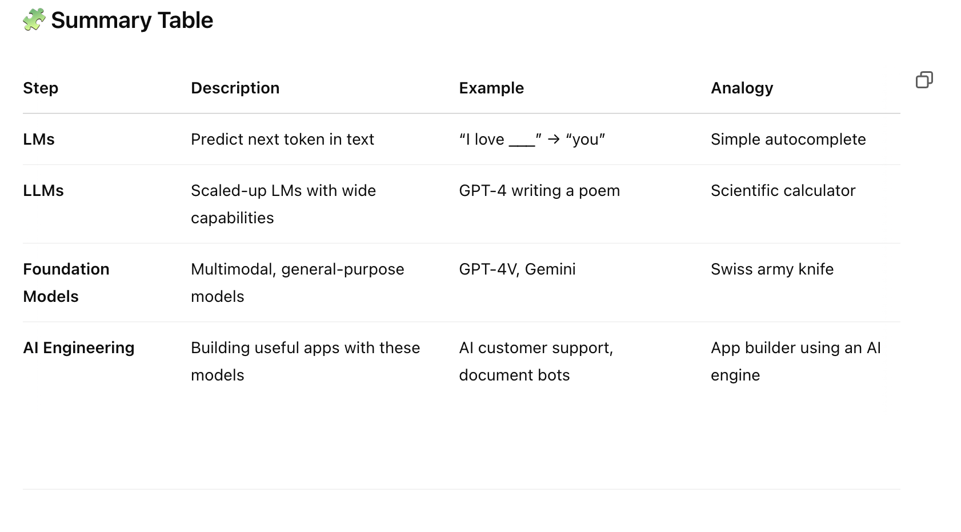

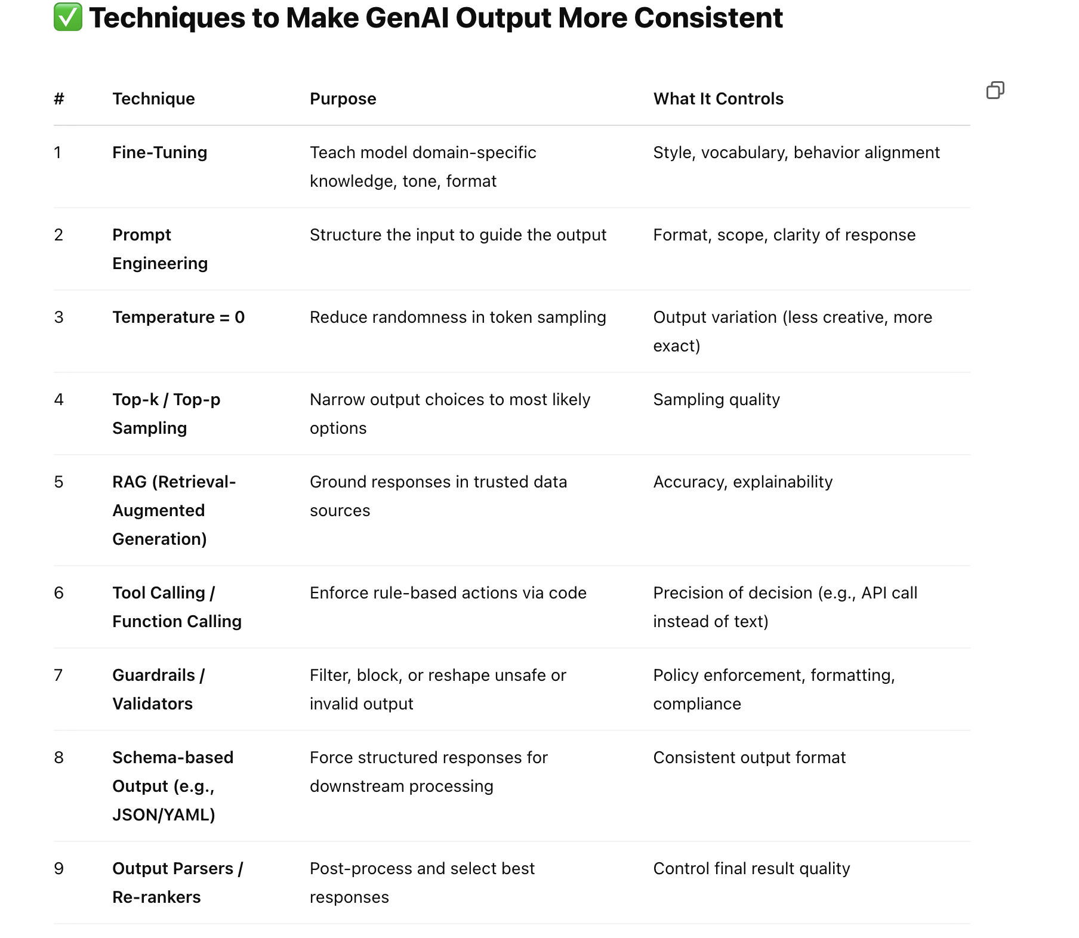

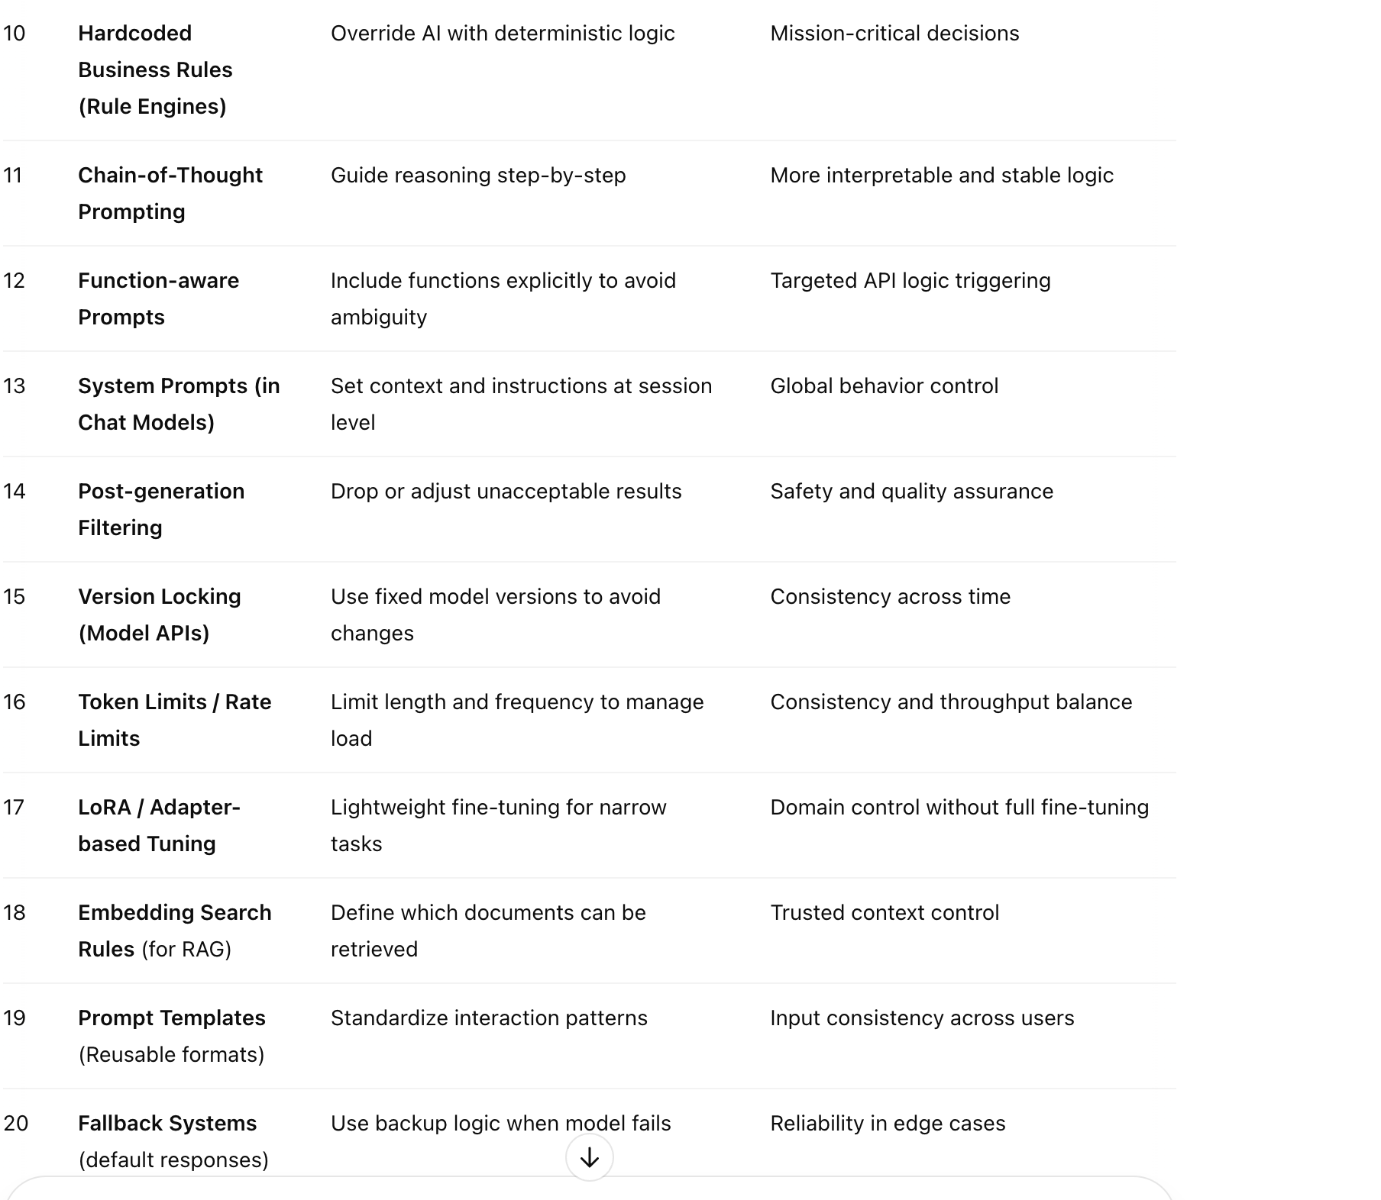

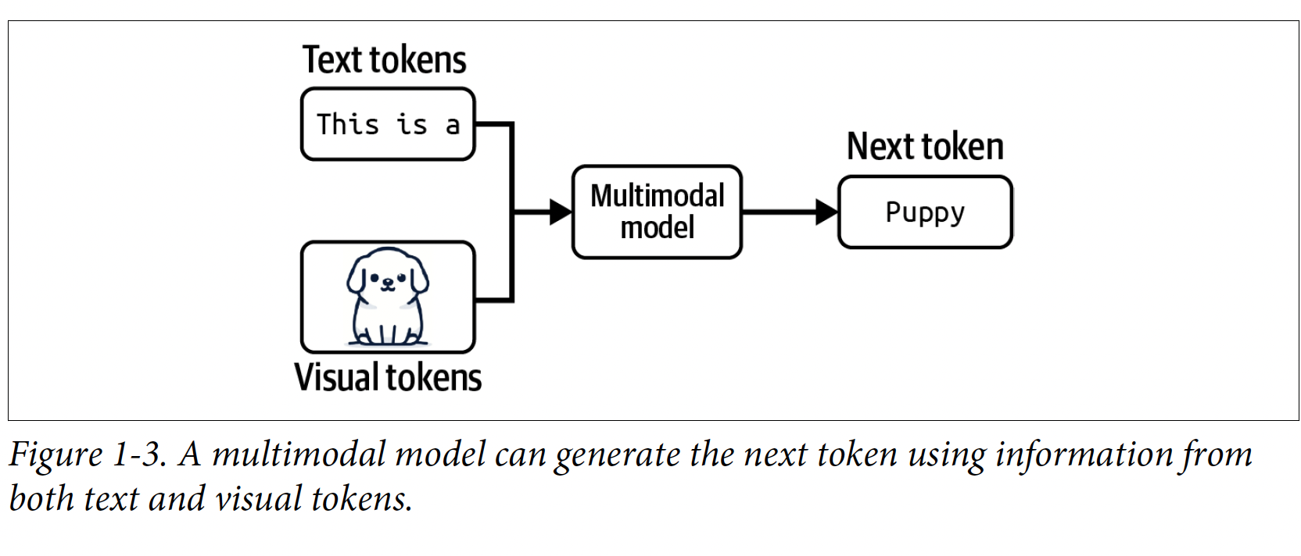

| **🧩 Technique** | **🔍 Description** | **💬 Example Prompt** |
| --- | --- | --- |
| **Zero-shot** | Ask a question or task with no example | “Translate this to French: *Hello, how are you?*” |
| **One-shot** | Give 1 example to guide the model | “Translate to French: ‘Good morning’ → ‘Bonjour’. Now translate: ‘Good night’ →” |
| **Few-shot** | Provide 2-5 examples to set a pattern | “Translate: ‘Hi’ → ‘Salut’, ‘Thanks’ → ‘Merci’. Now: ‘Sorry’ →” |
| **Chain-of-Thought (CoT)** | Ask the model to explain its reasoning step-by-step | “Is 67 divisible by 3? Think step by step.” |
| **ReAct (Reason + Act)** | Let the model reason *and* take actions (like tool calls) | “What’s the population of Tokyo? First think, then search online.” |
| **Instruction Prompting** | Clearly instruct what to do and how | “Write a polite email to reschedule a meeting to next week.” |
| **Role-based Prompting** | Assign a role/persona to guide tone & output | “You are a career coach. Give advice to someone struggling with interviews.” |
| **Skeleton Prompting** | Provide a response format to control structure | “Write a report with: Title, Summary, 3 Bullet Points, and a Conclusion.” |
| **Output Format Control** | Define the exact structure (JSON, CSV, etc.) | “Give a list of 3 fruits in JSON format with keys: name, color.” |
| **Contextual Prompting** | Supply external data the model should use | “Based on the policy document below, answer this customer query…” |
| **Self-refinement (Reflective Prompting)** | Ask model to critique or improve its own answer | “Write a short story, then suggest 3 ways to improve it.” |
| **Multi-turn Prompting** | Use conversation flow to guide learning across turns | **User**: "Explain photosynthesis." → **Next**: "Now explain it like I’m 5." |

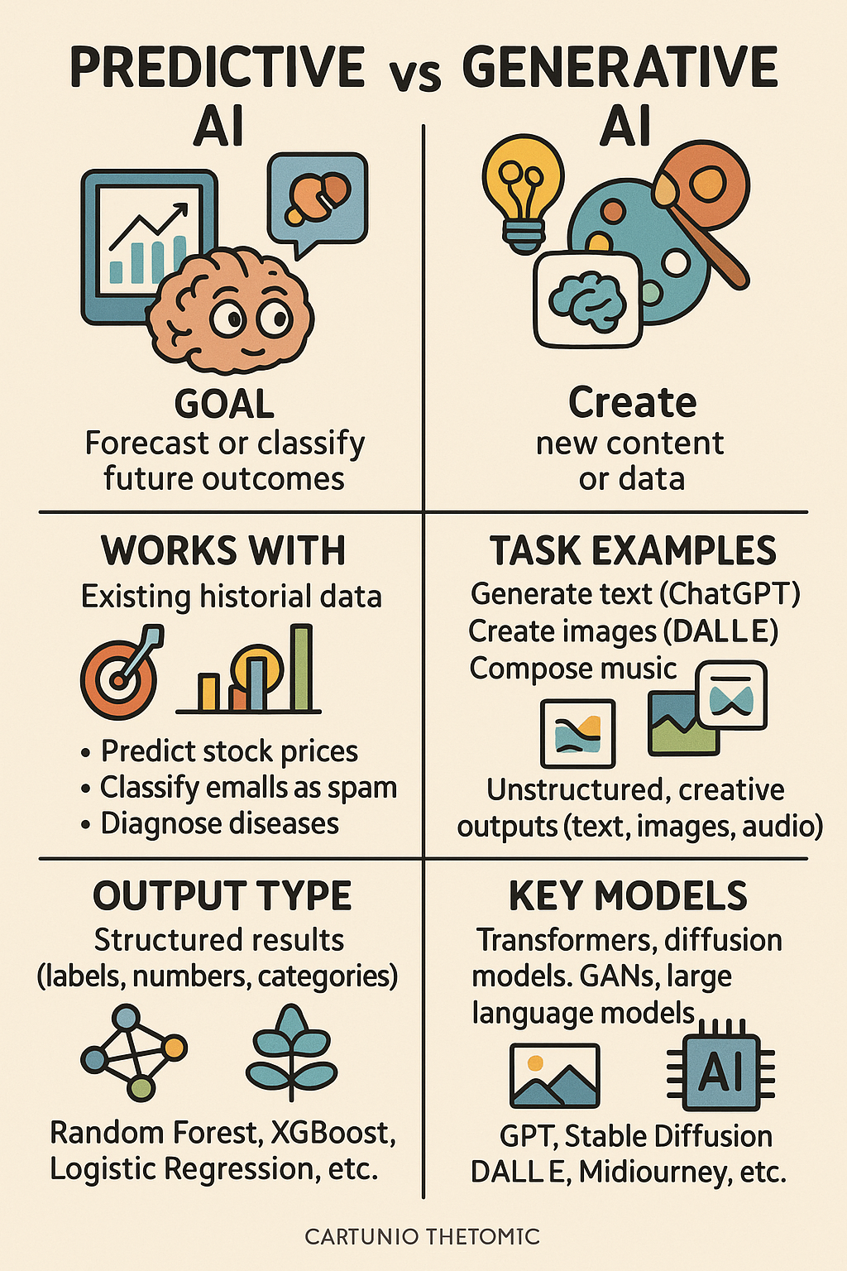

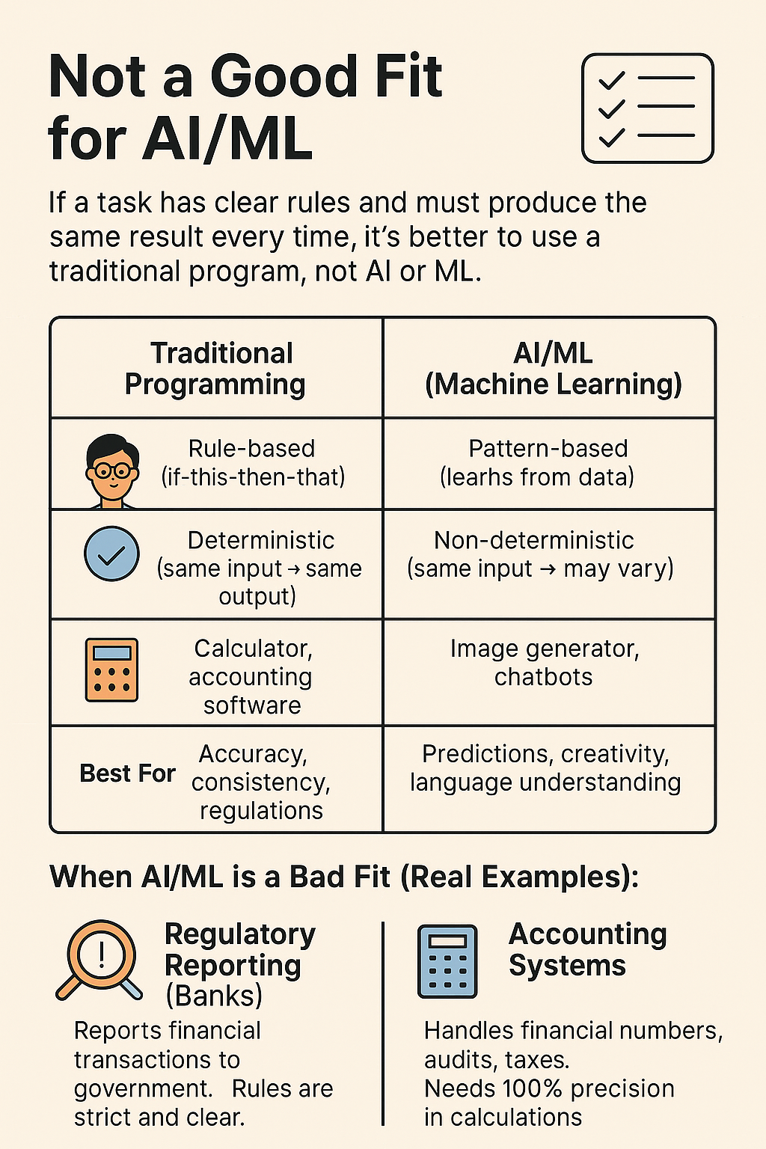

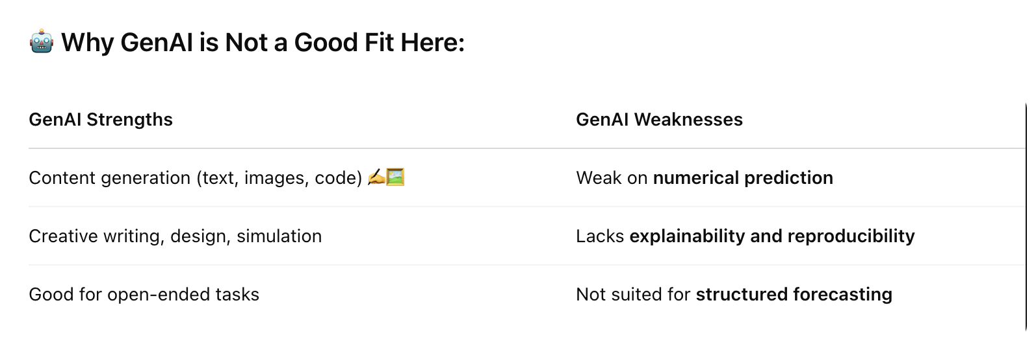

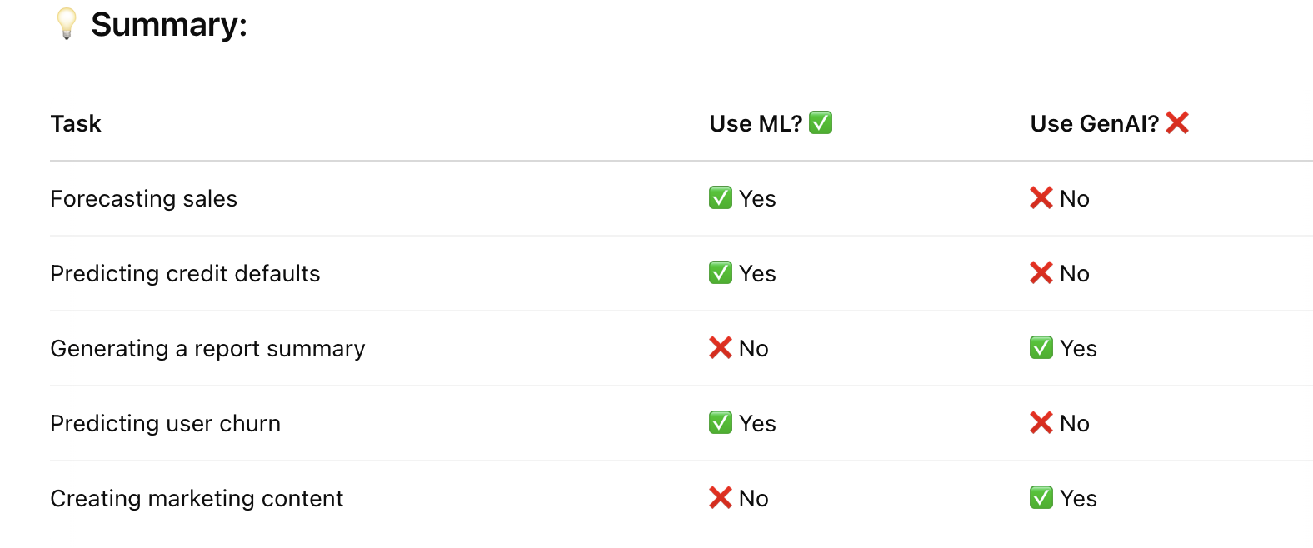

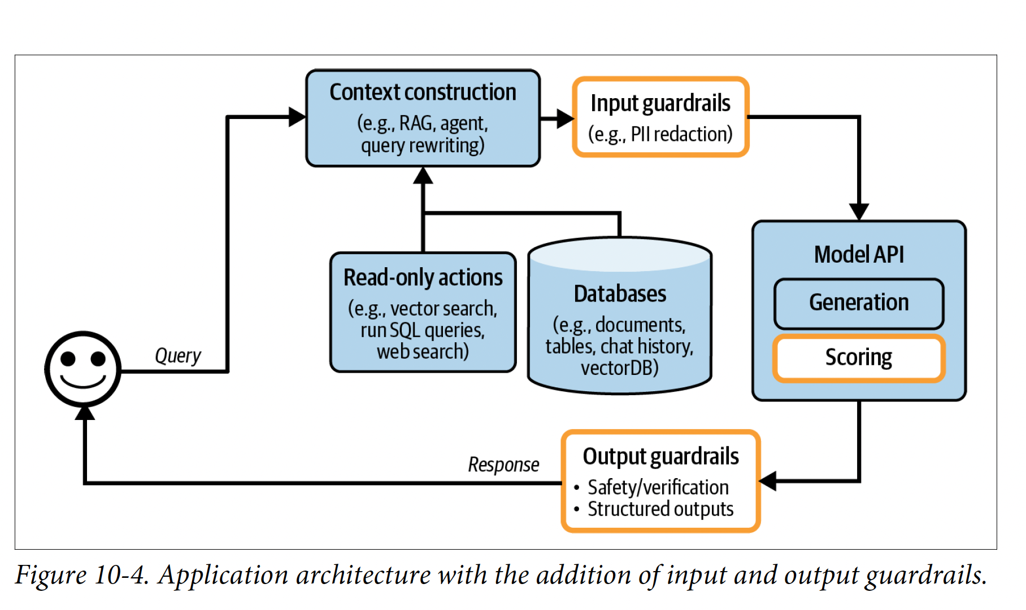

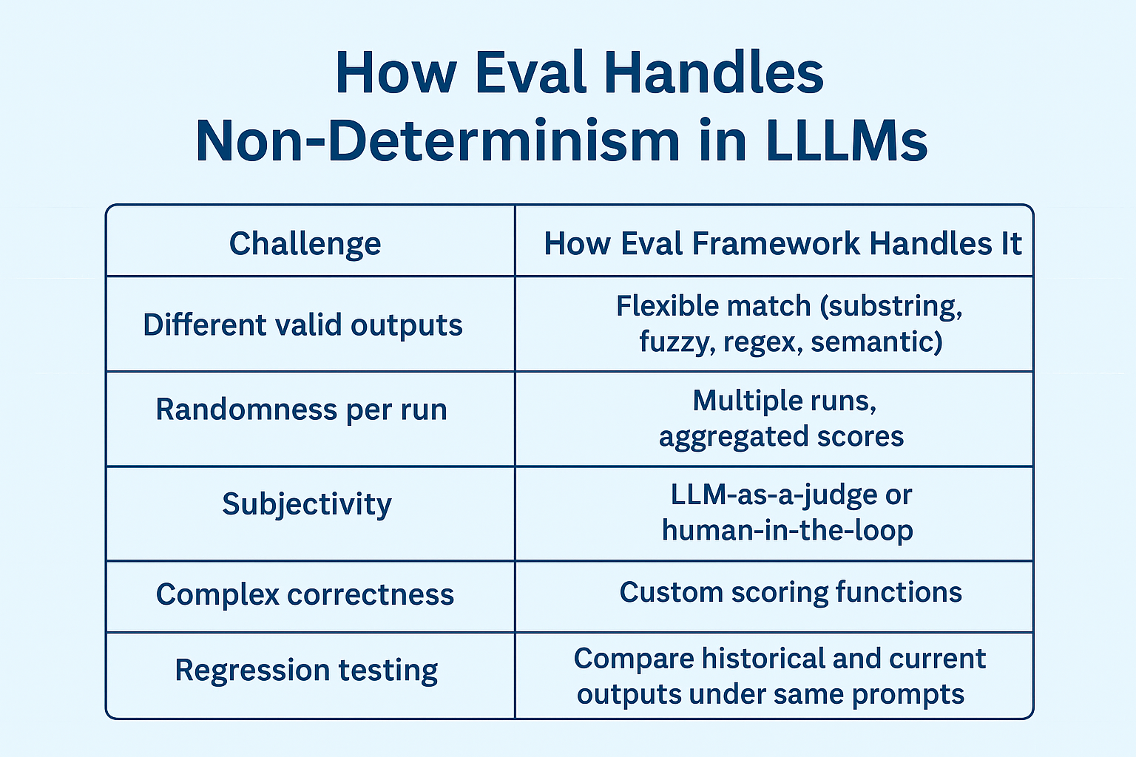

Book Generative AI for financial services

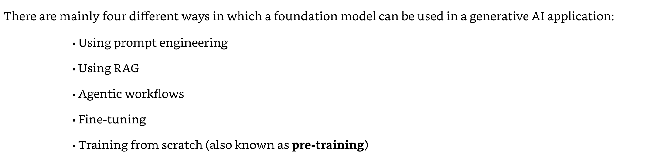

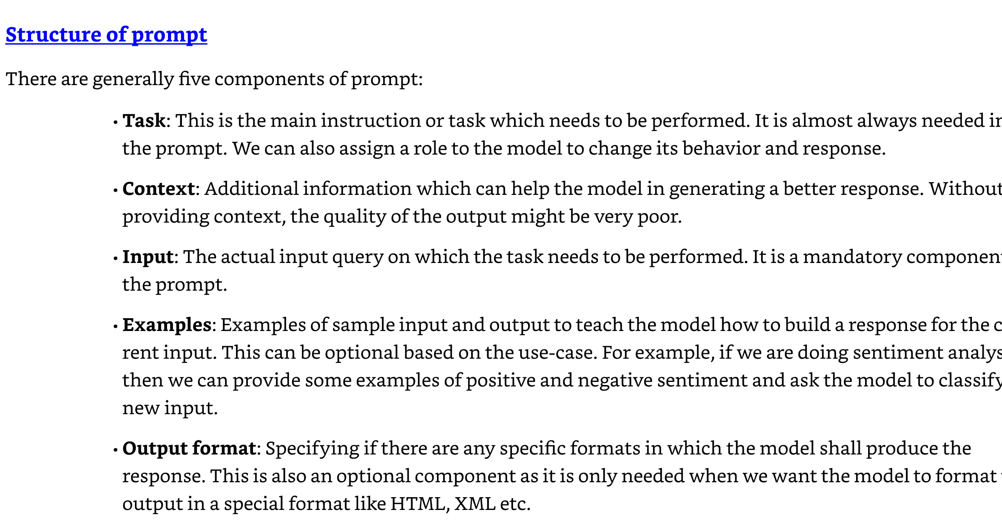

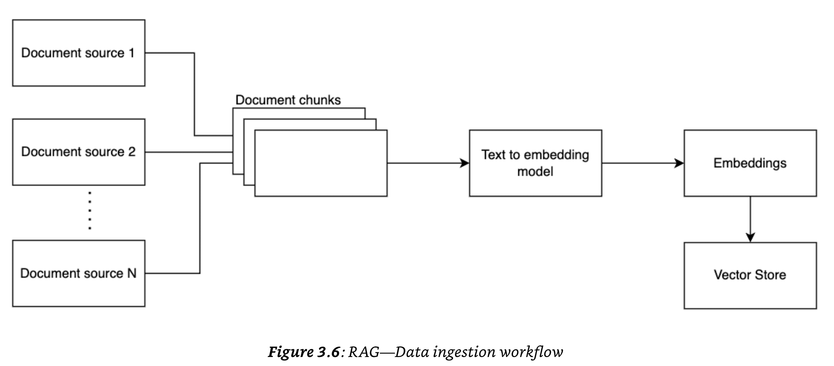

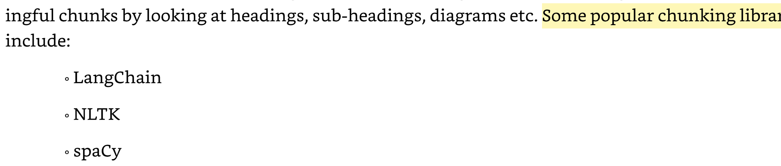

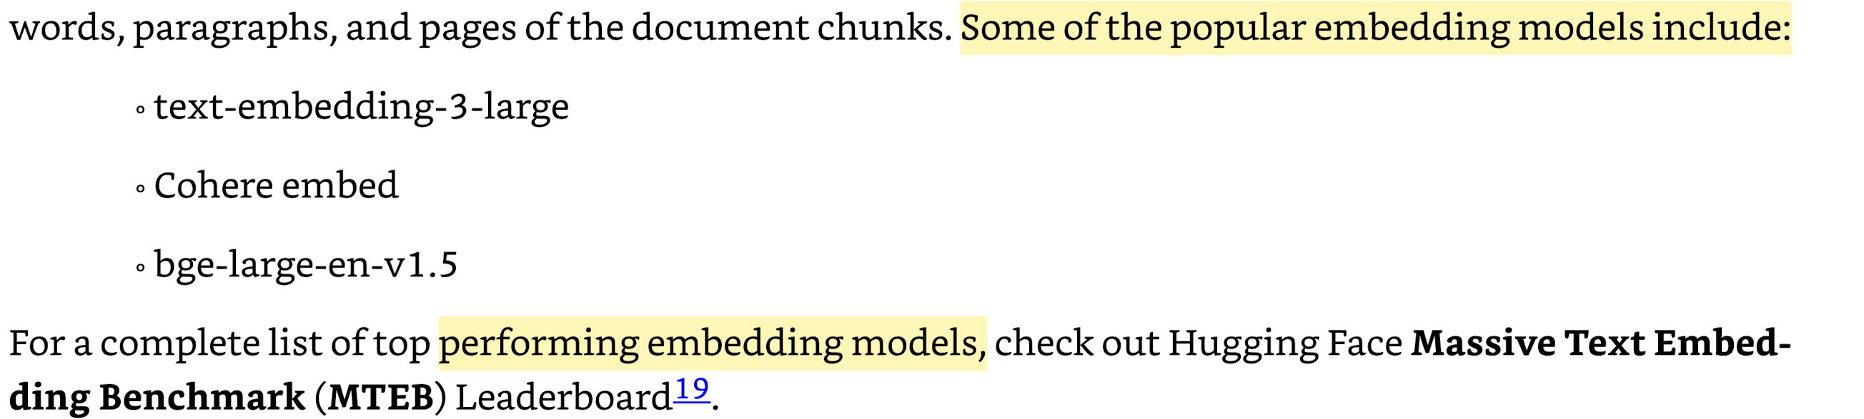

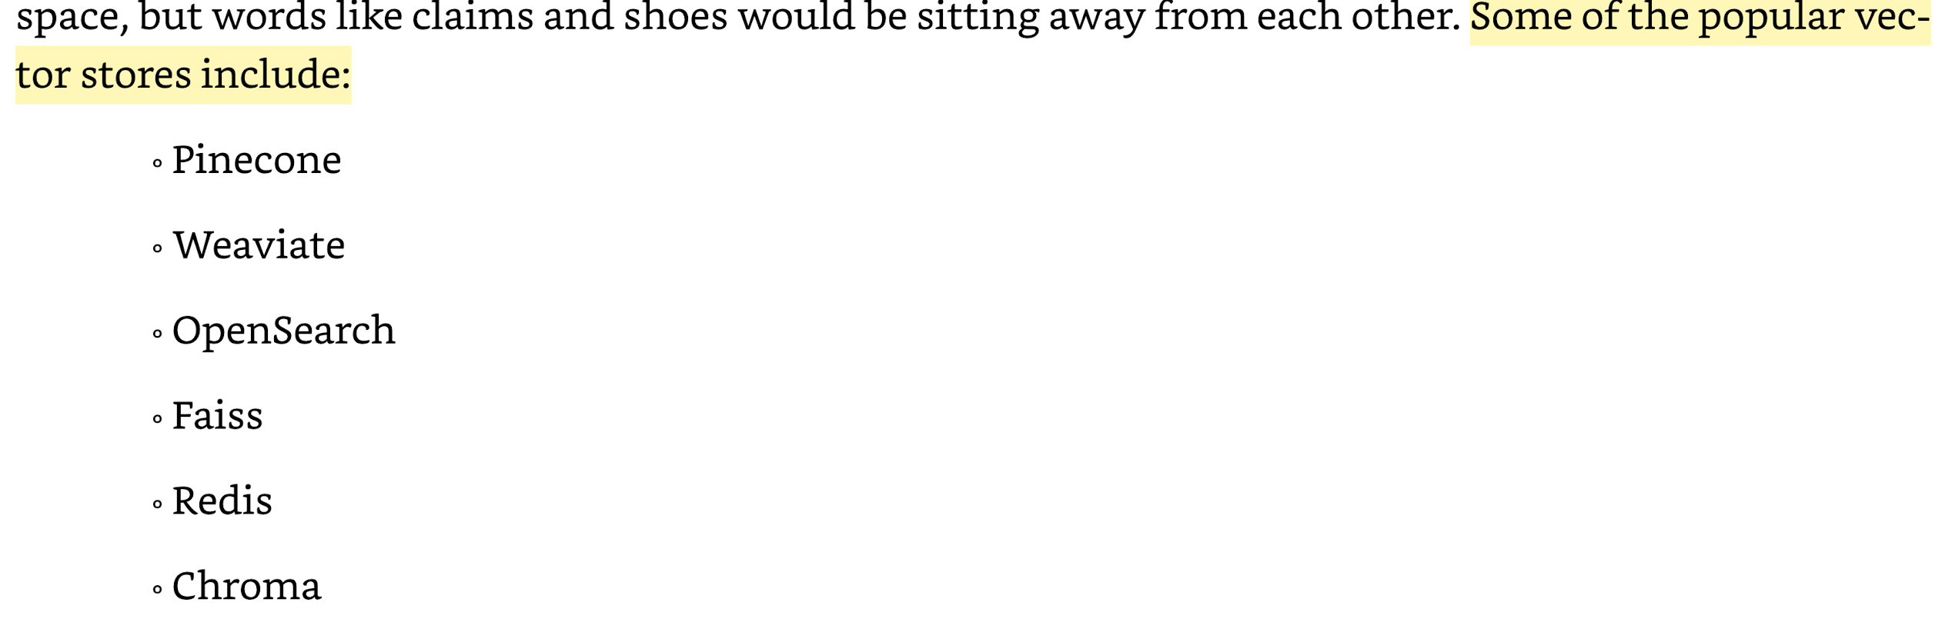

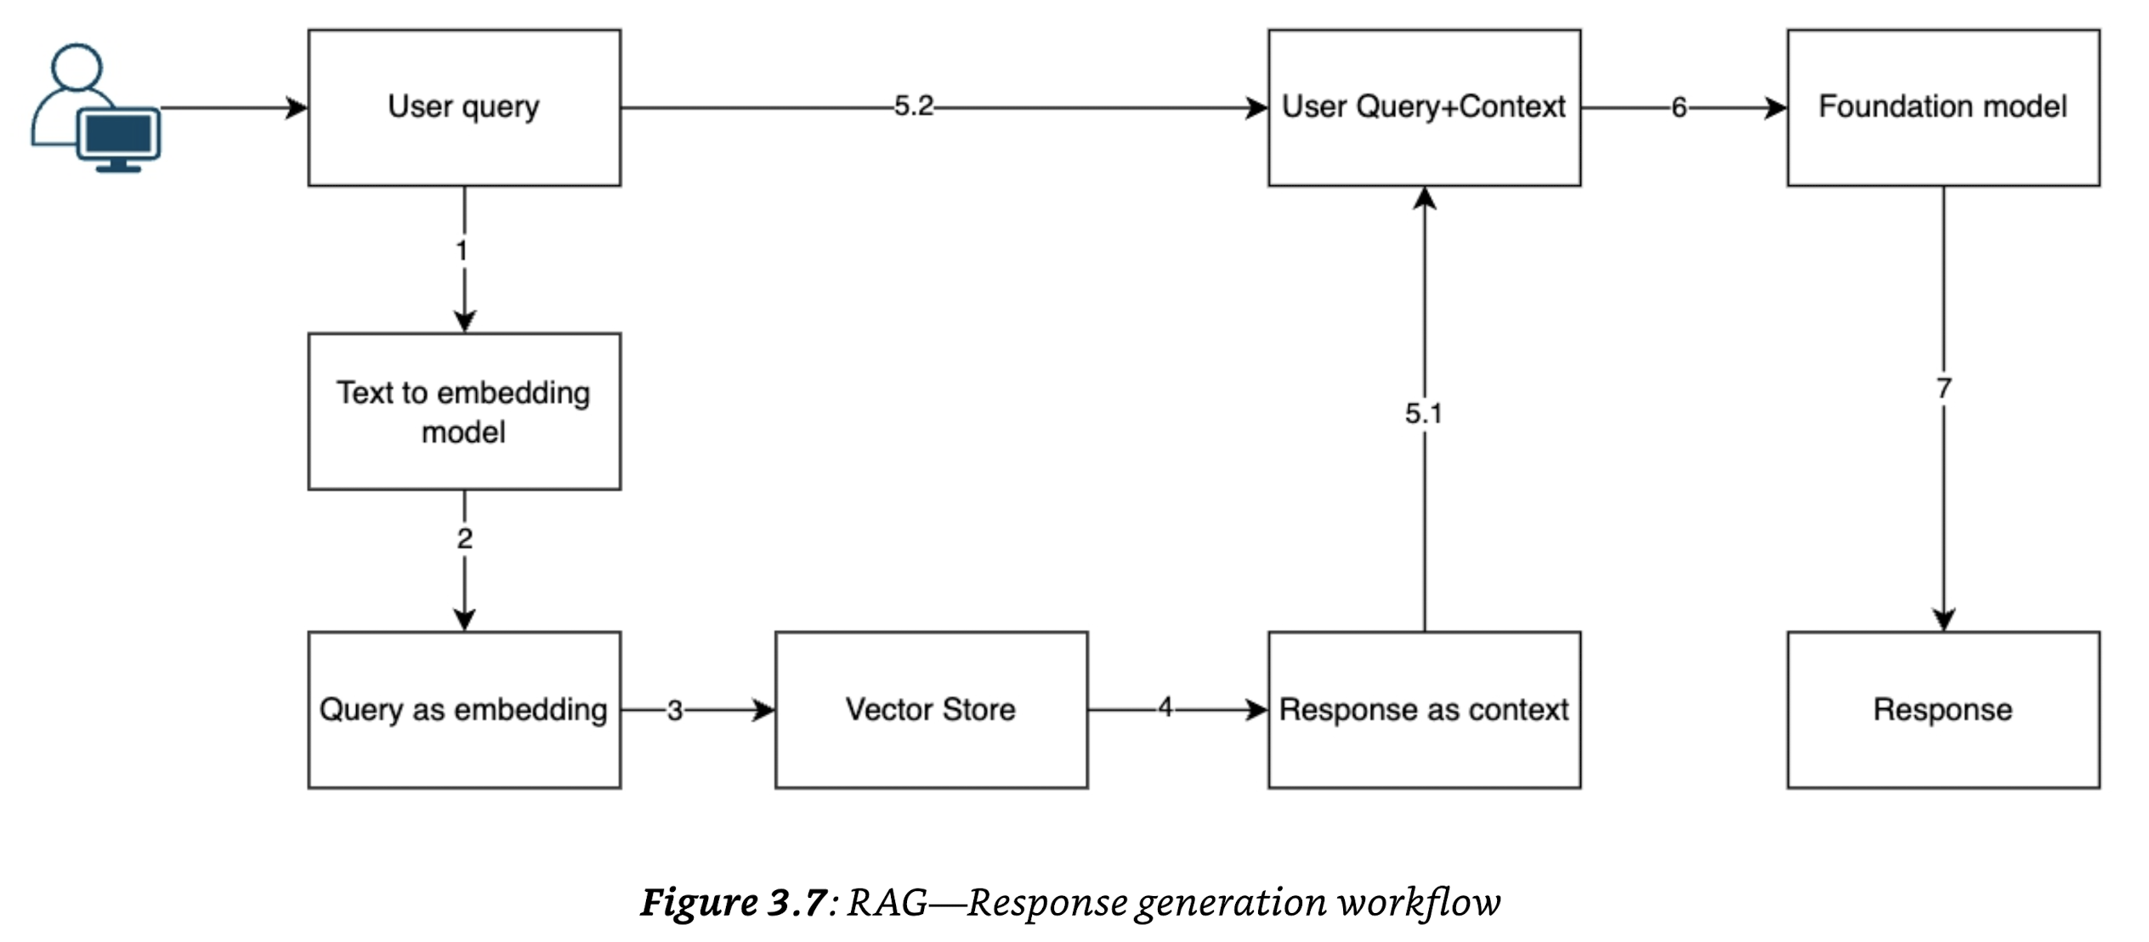

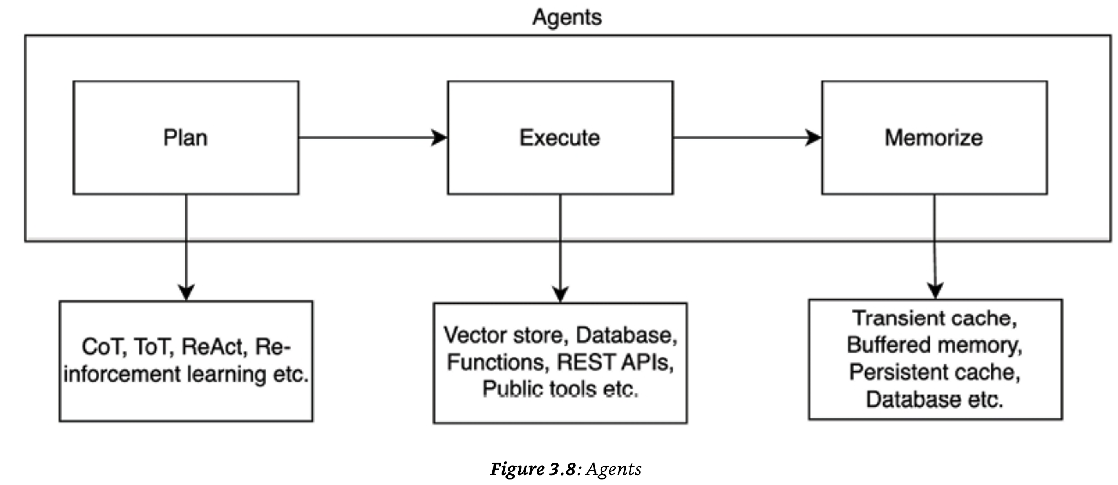

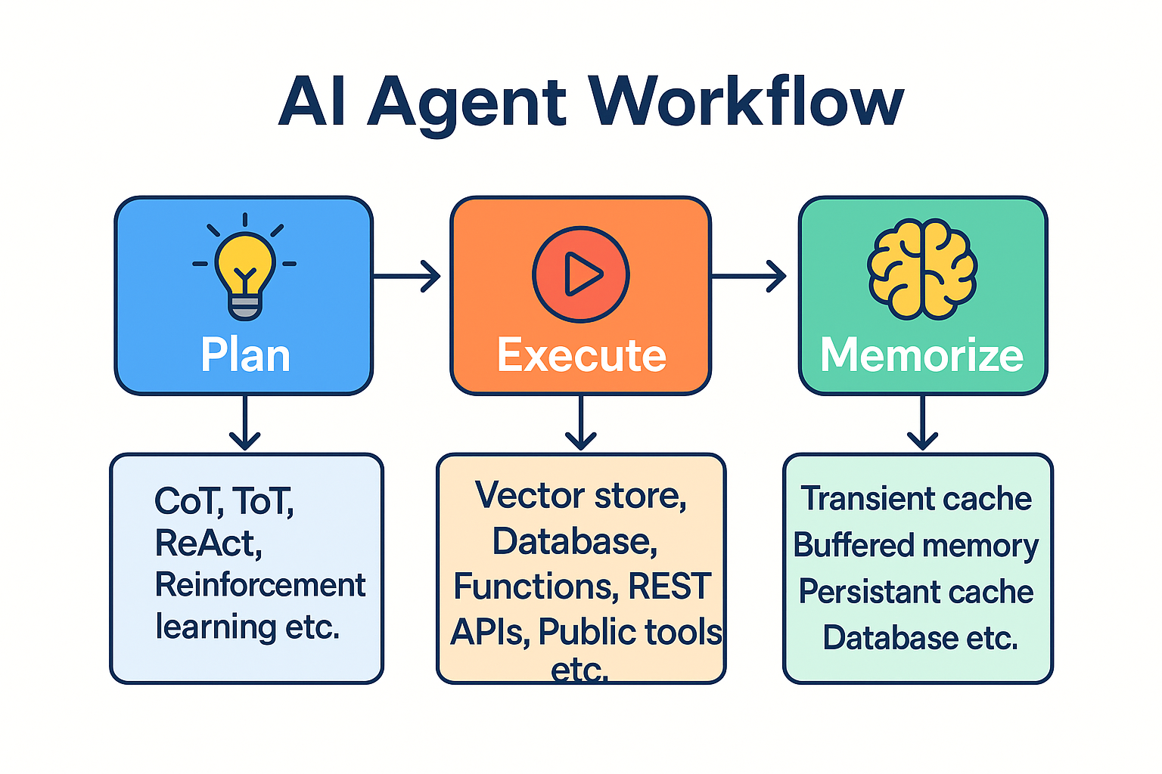

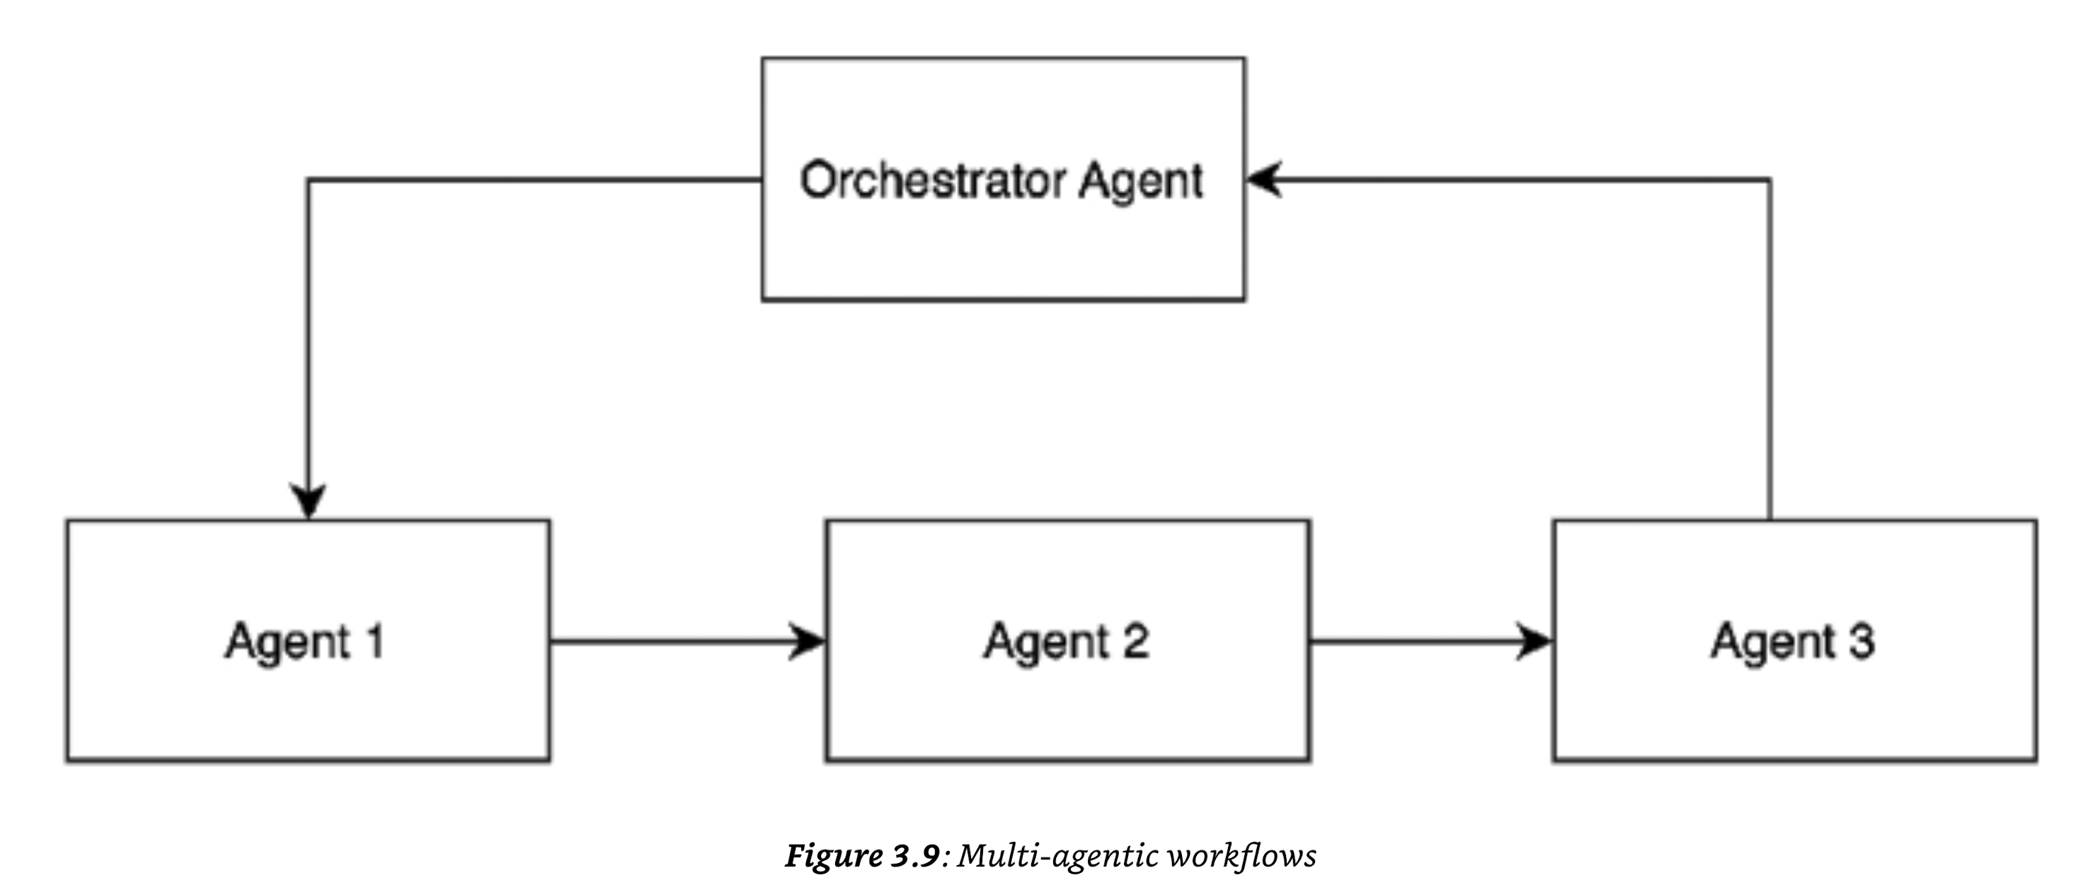

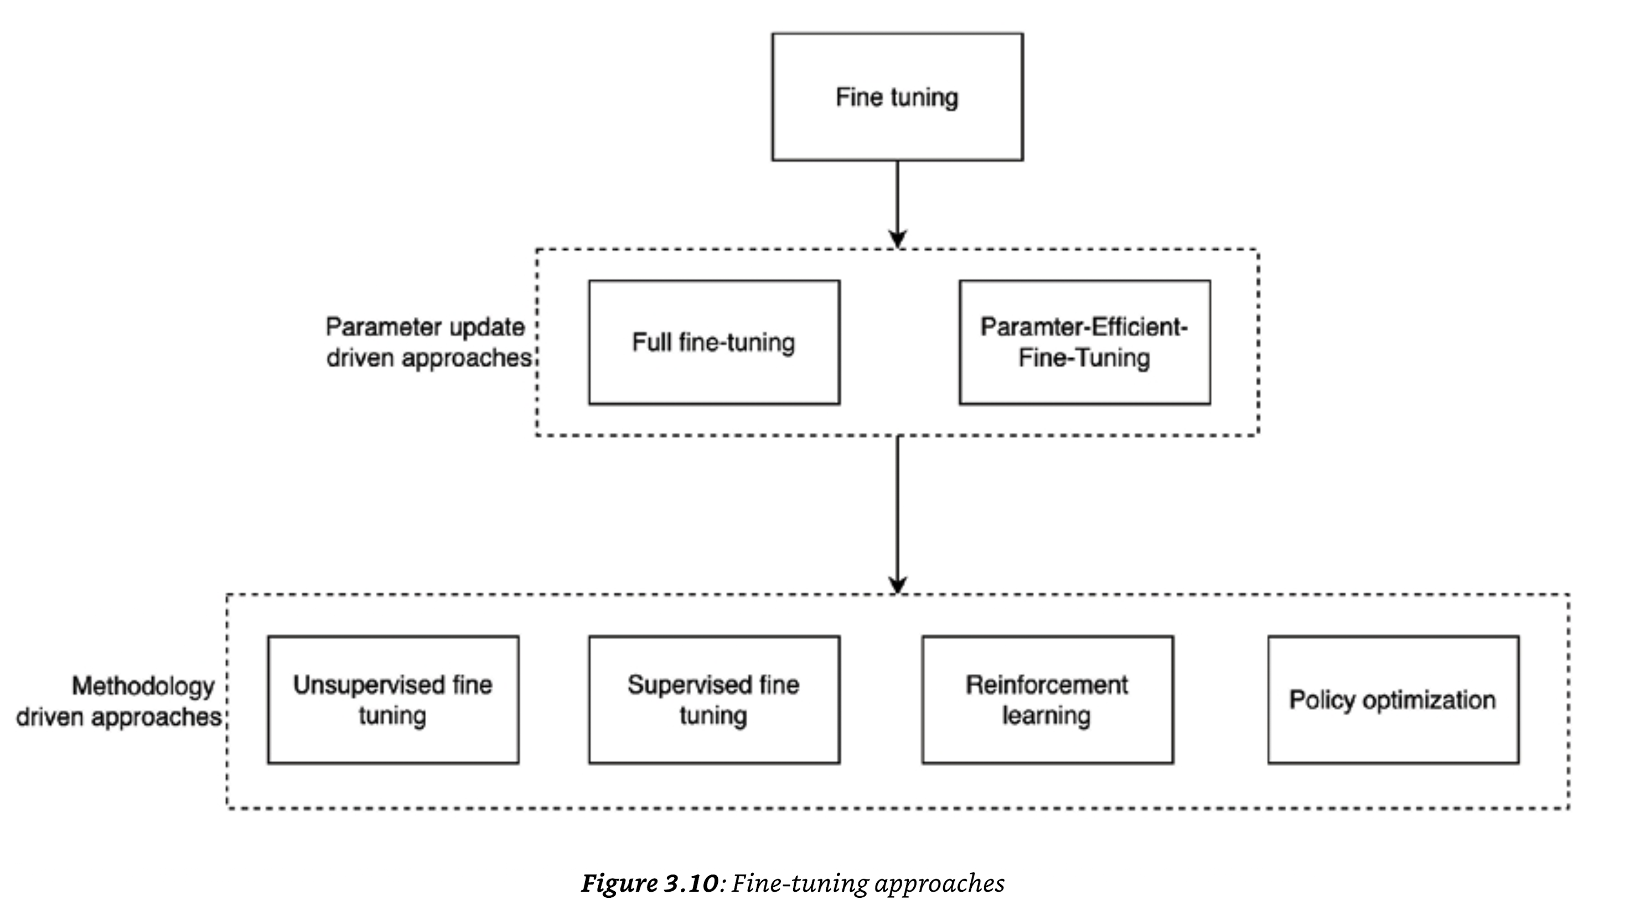

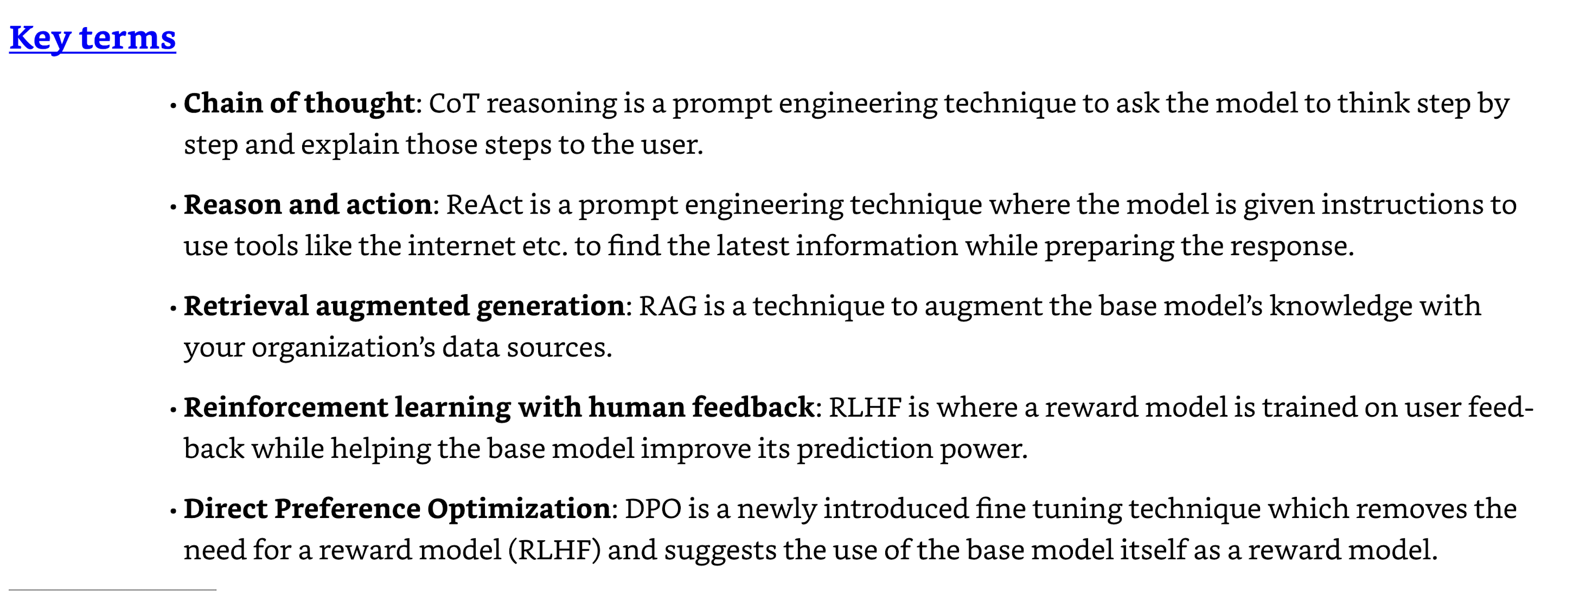

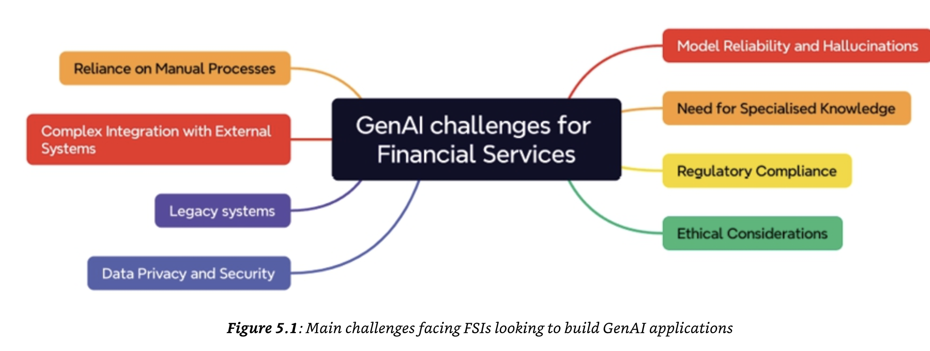

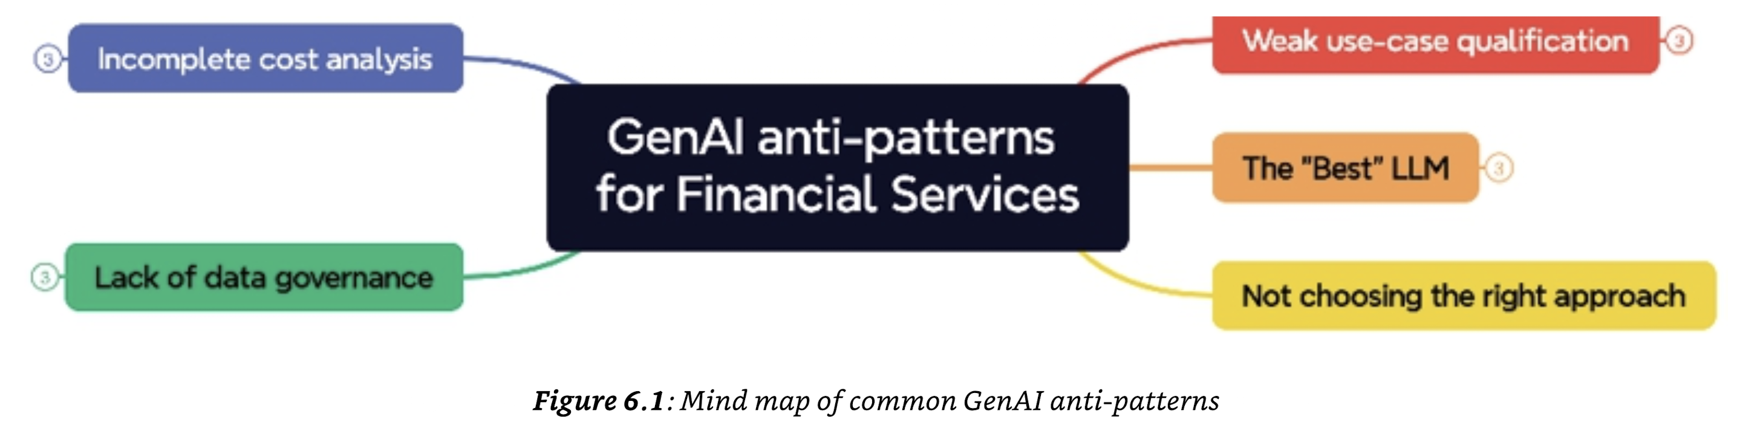

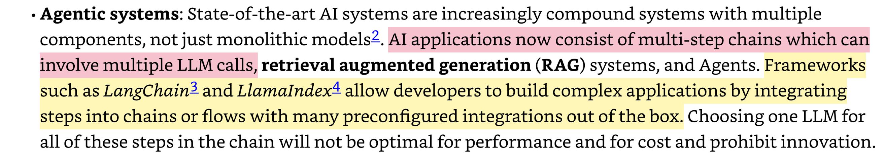

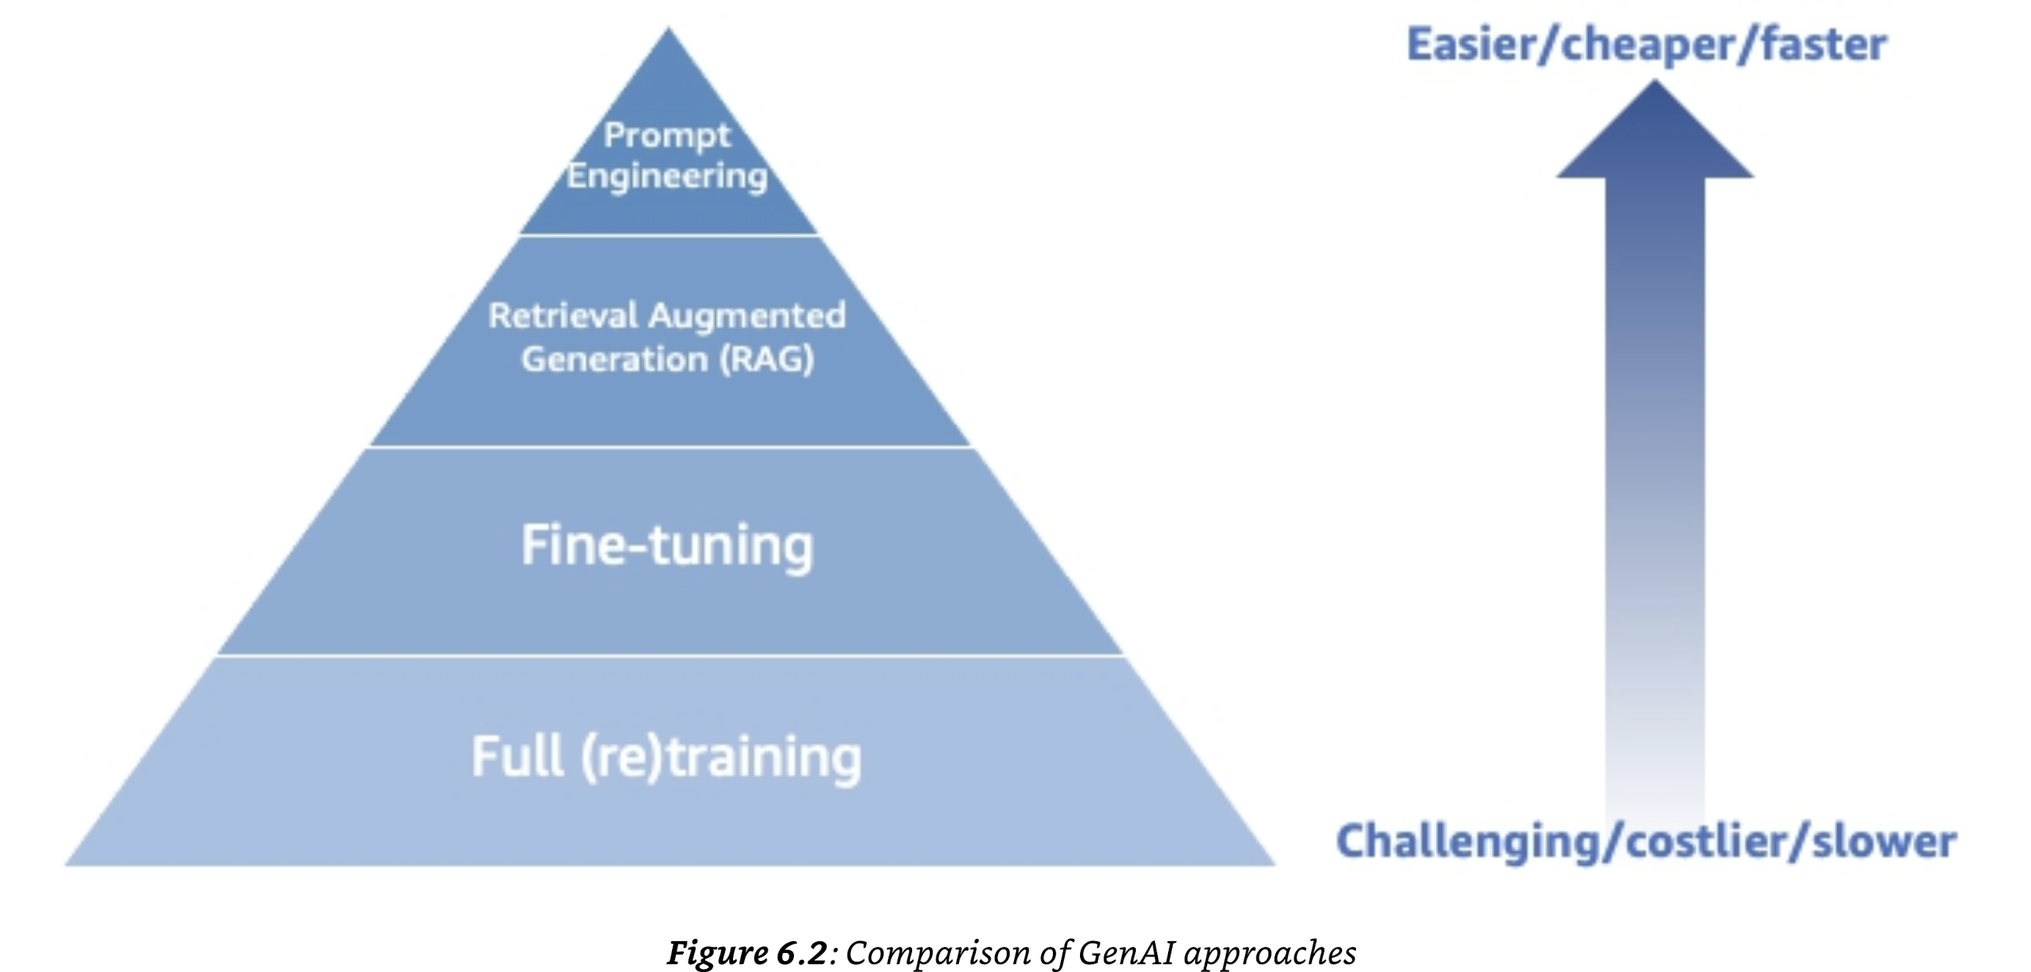

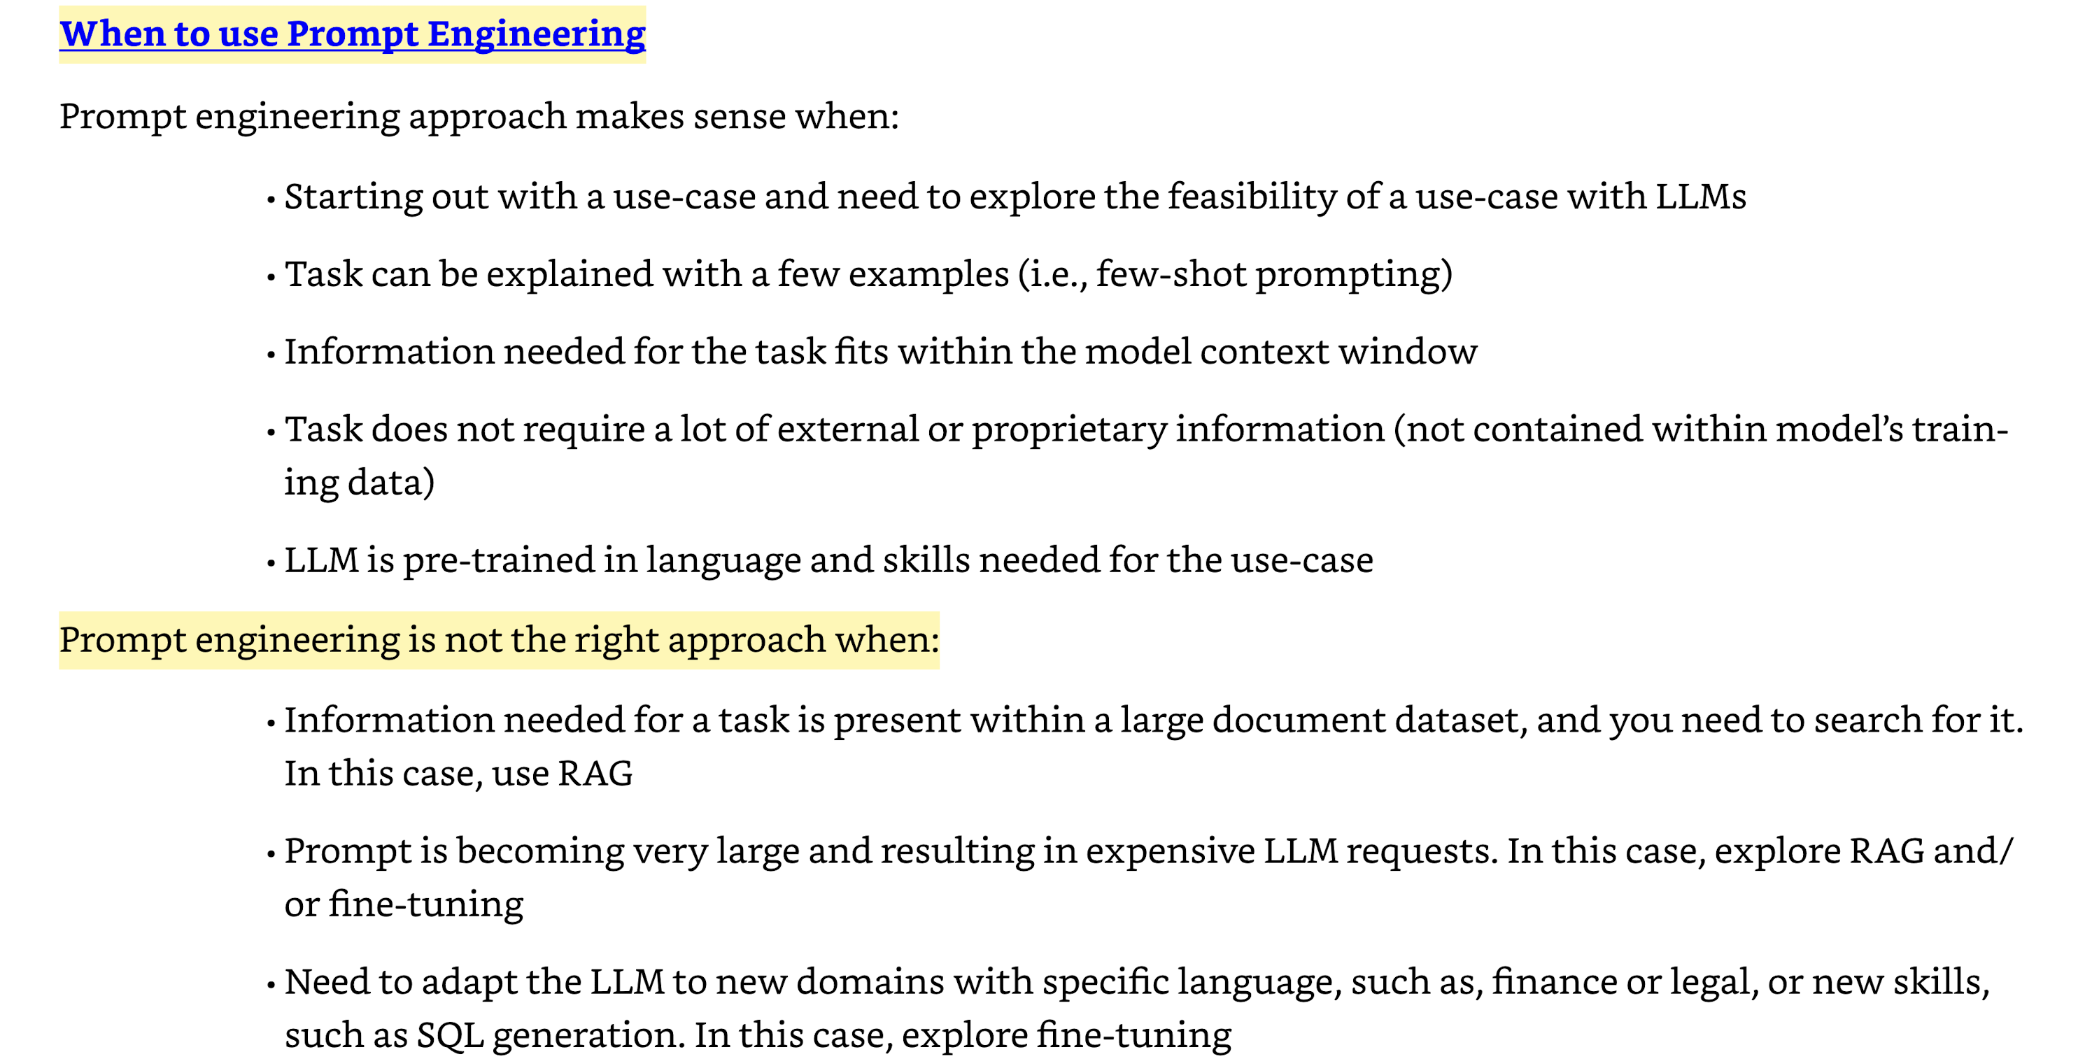

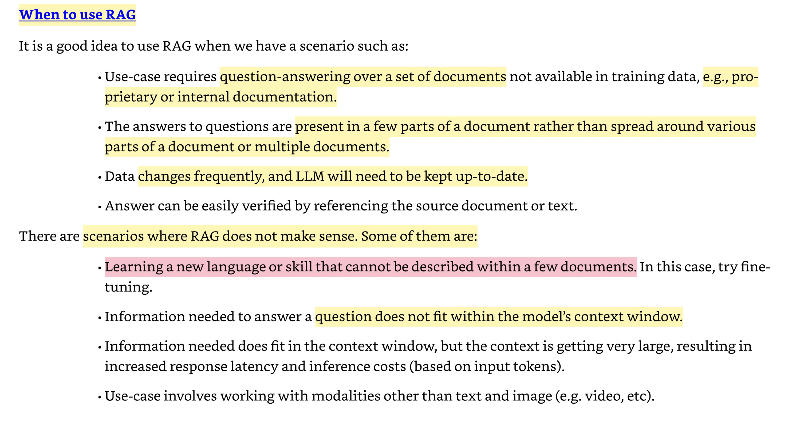

When to use the Agentic system

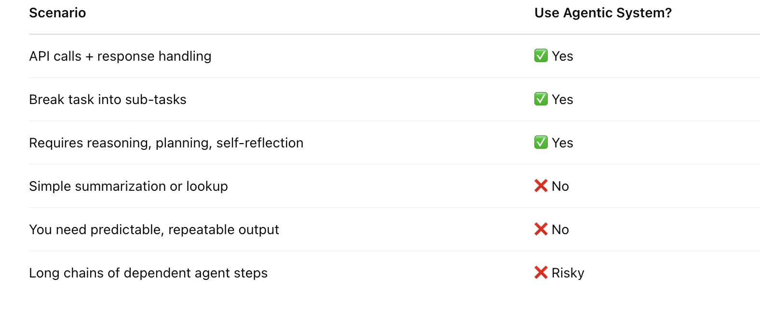

When to use the fine tuning

